Emre Can Şen- 21902516

Section-2

Lab-01

Handwritten Solutions

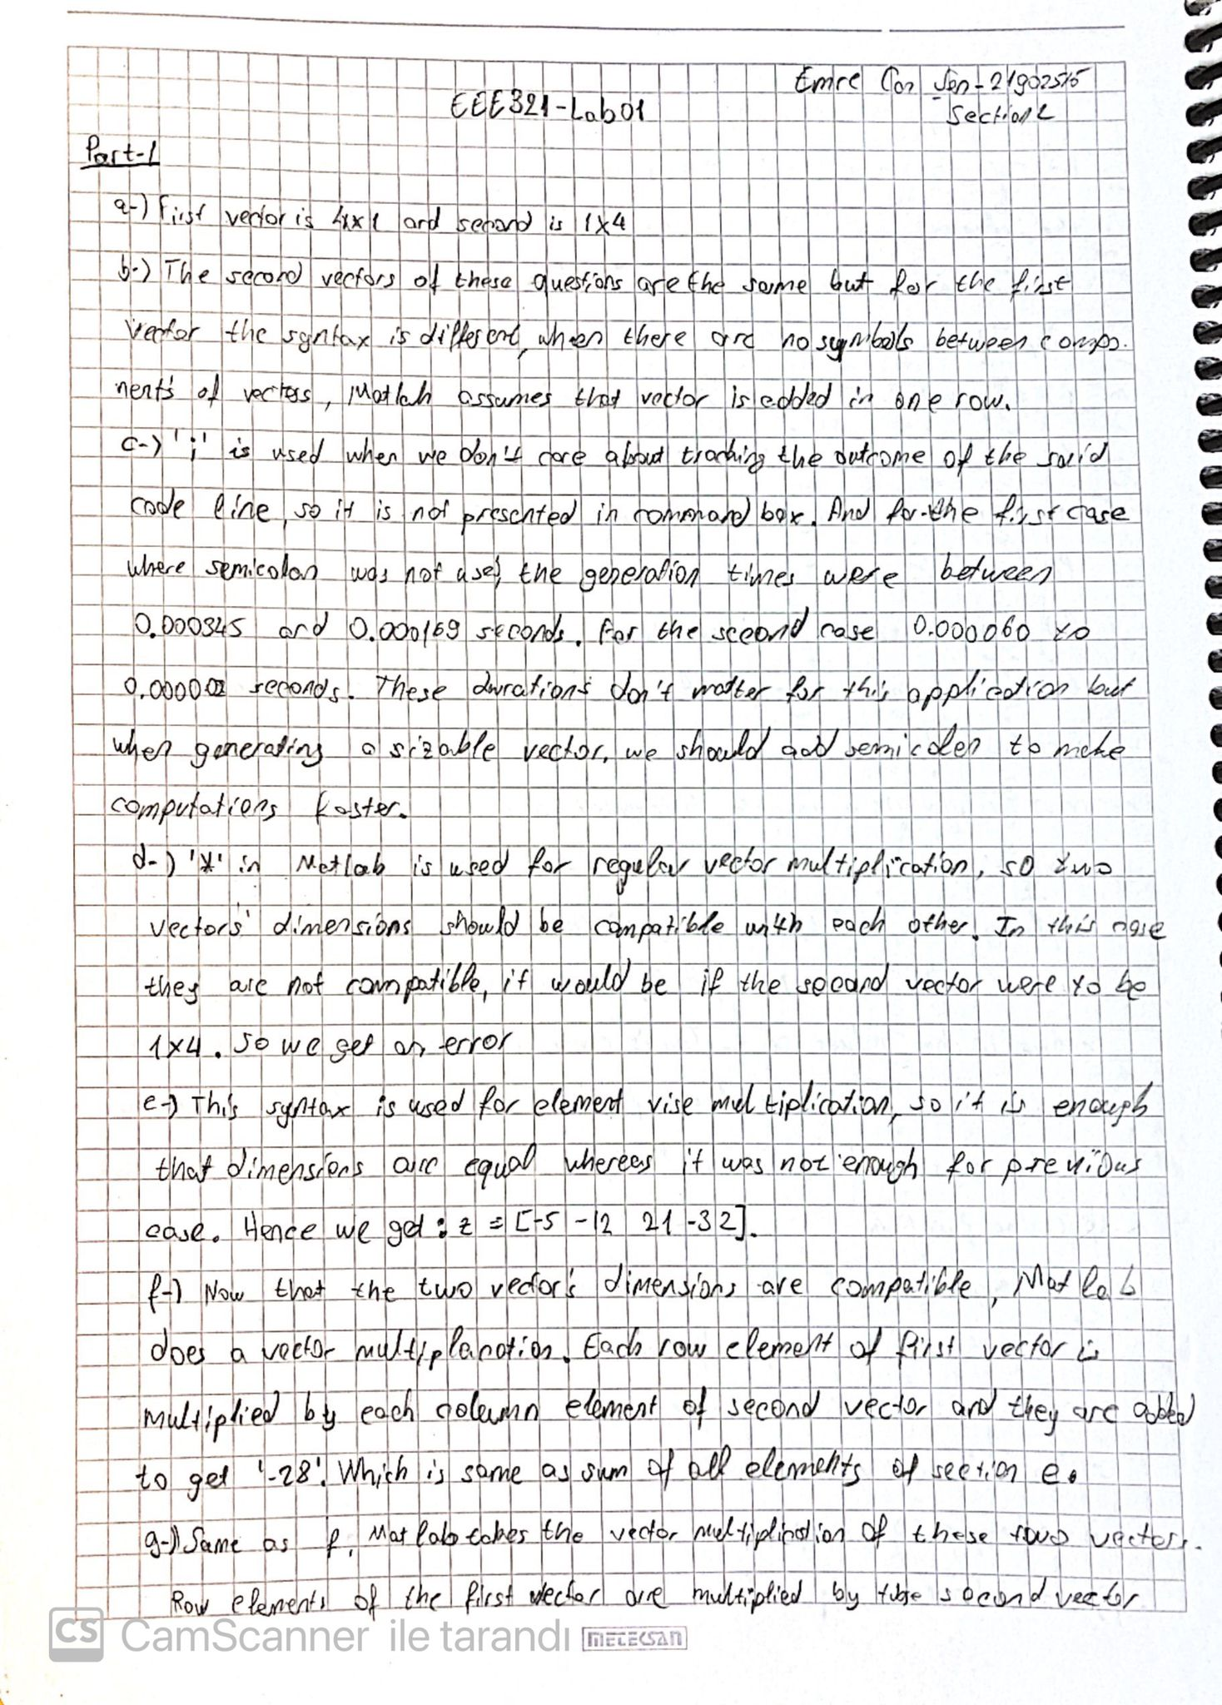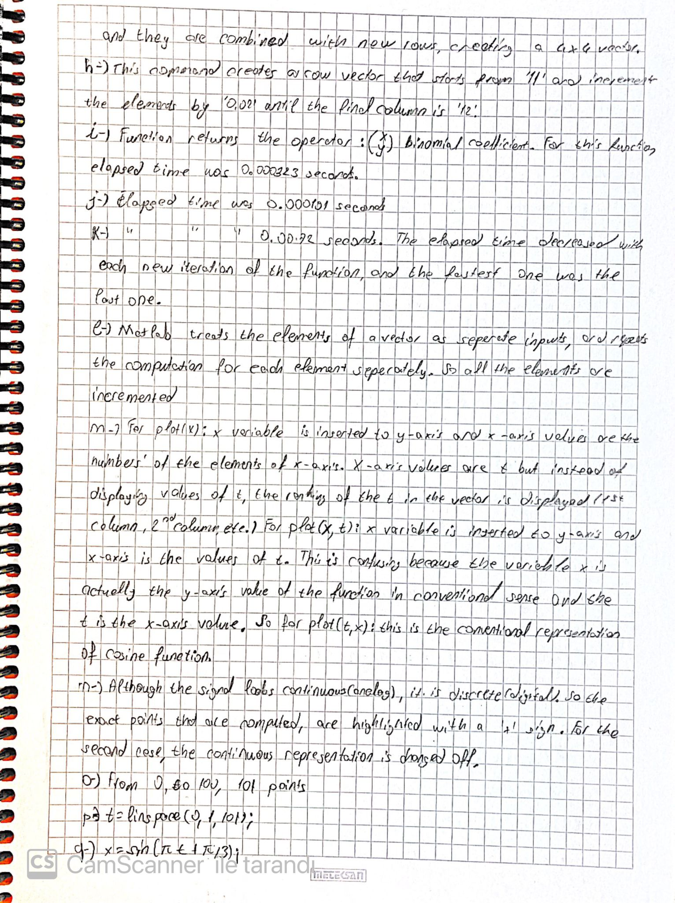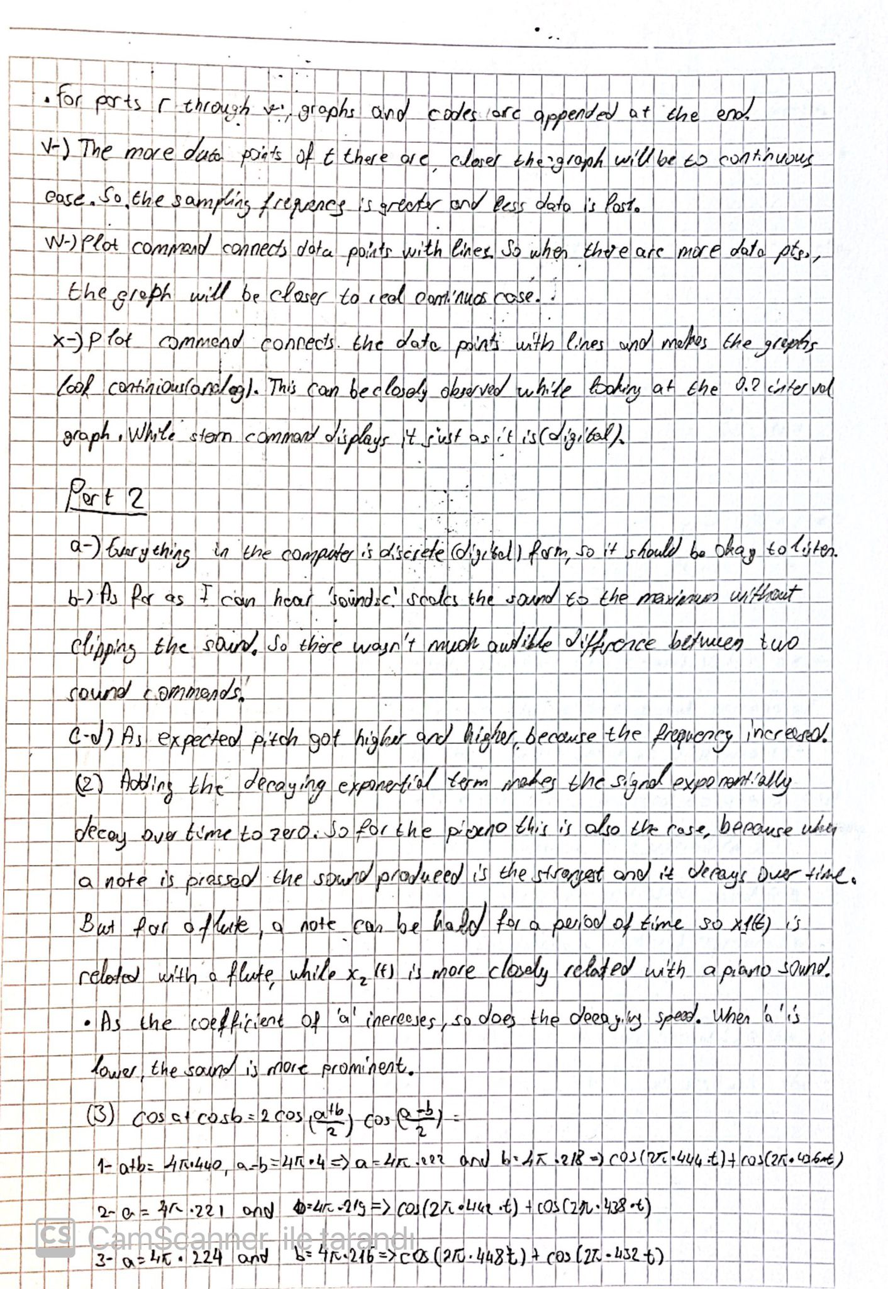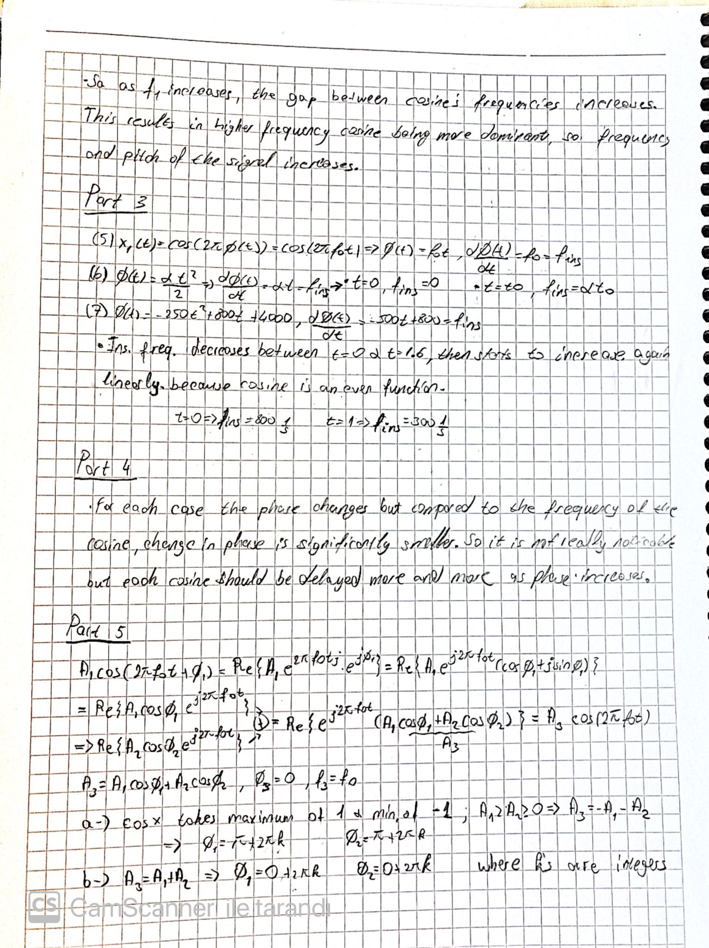

Part 1

r-

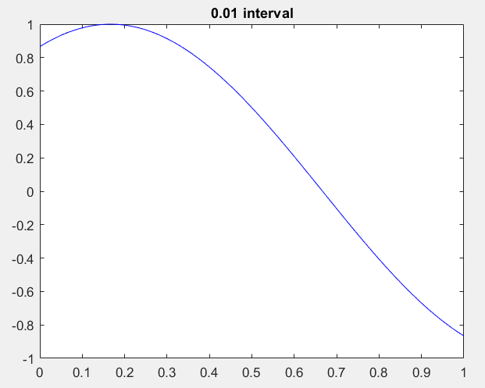

Figure 1- 0.01 Interval Graph

s- t=[0:0.025:1]; or t=linspace(0,1,41);

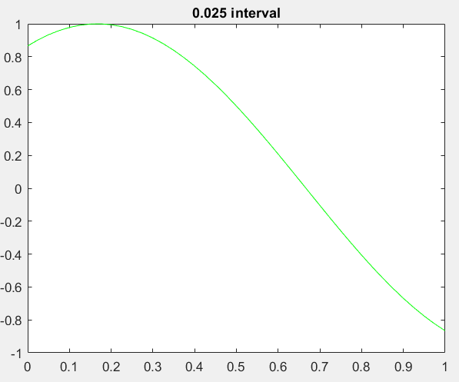

Figure 2- 0.025 Interval Graph

t-

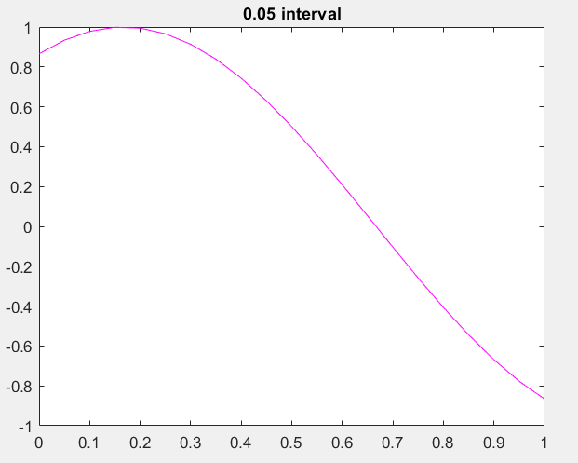

Figure 3- 0.05 Interval Graph

u-

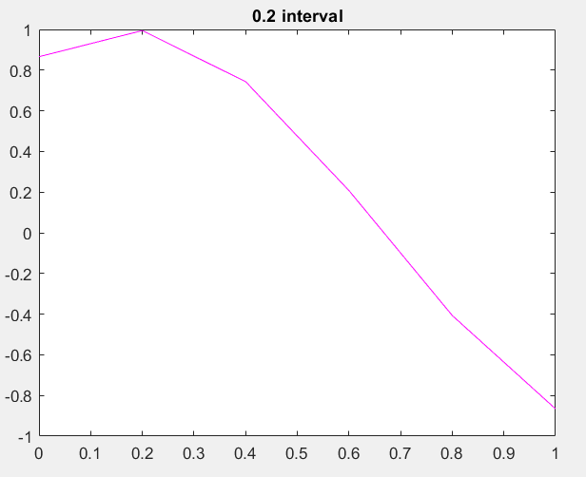

Figure 4- 0.2 Interval Graph

v-

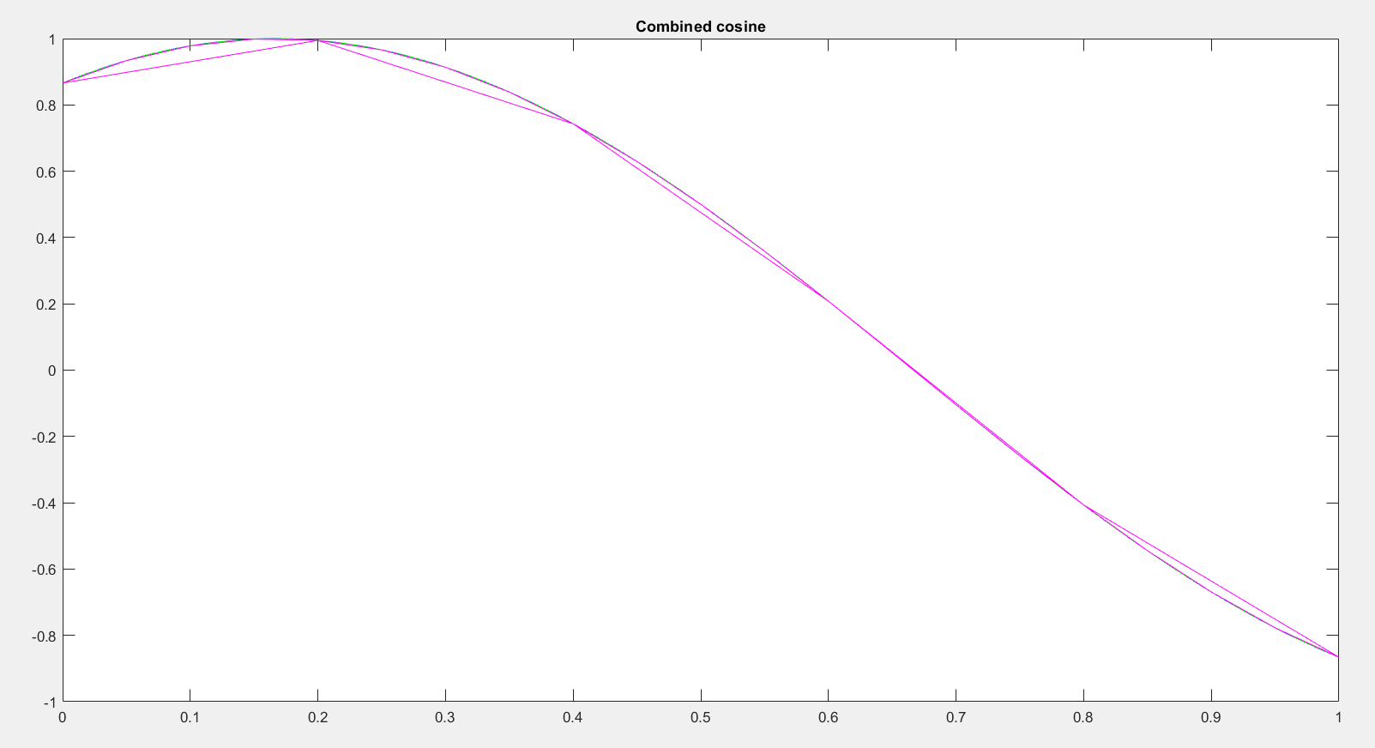

Figure 5- All Graphs Combined

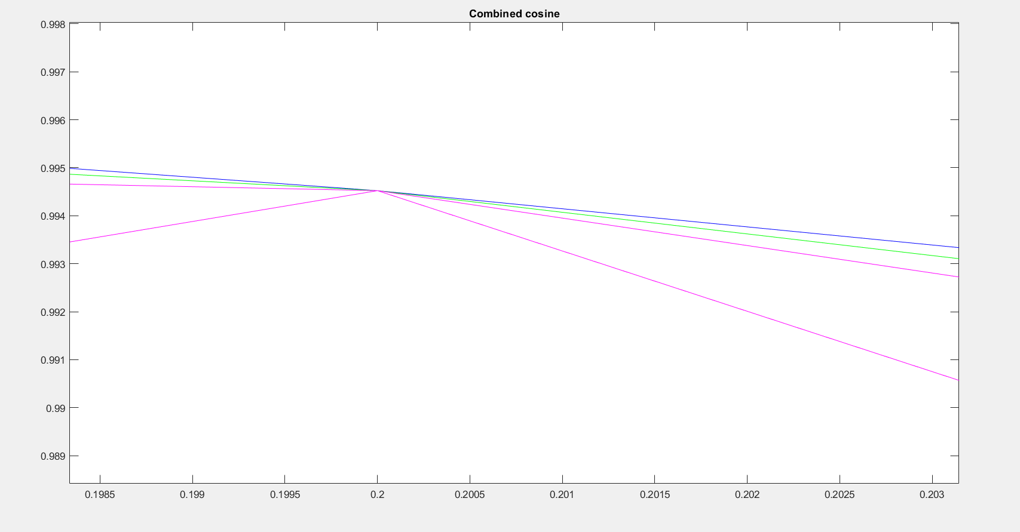

Figure 6- Zoomed Combined Graphs

Part 2

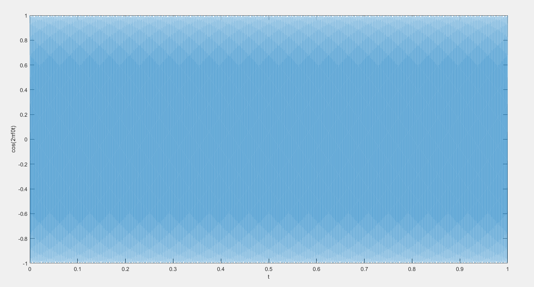

Figure 7- cos(2πf0t) vs time

(2)

t=[0:1/8192:1];

a=8;

f=880;

x2= (exp(-a\*t)).\*cos(2\*pi\*f\*t);

figure

plot(t,x2);

ylabel('e^-at\*cos(2?f0t)');

xlabel('t');

sound(x2)

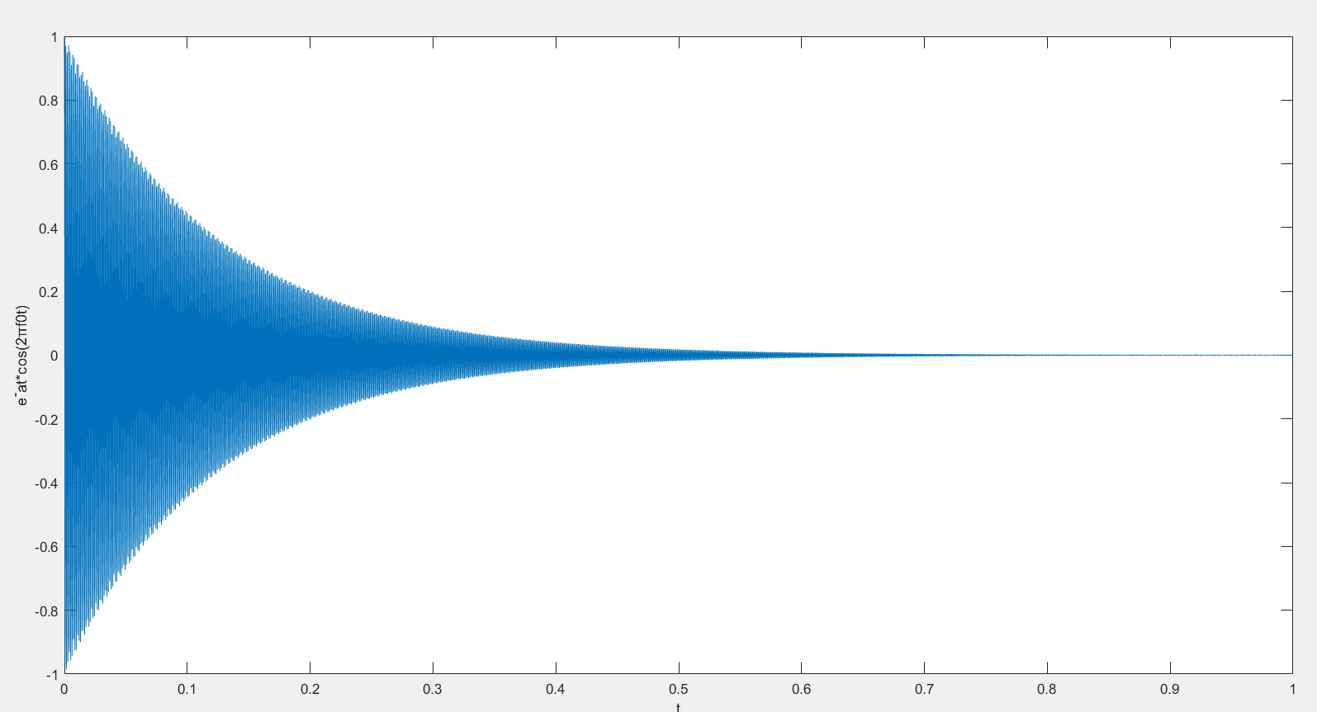

Figure 8- e^−αt\*cos(2πf0t) vs time

(3)

Part 3

Part 4

a- It doesn’t change???

Part 5

MATLAB Codes

%{

tic

x=[-5, 1.2, 1/2, 3];

toc

tic

for i=40

x=nchoosek(50,i);

end;

toc

x=zeros(1)

tic

x=nchoosek(50,40)

toc

figure

t=linspace(0,1,101);

x=sin(pi\*t+pi/3);

plot(t,x,'b');

title('0.01 interval')

hold on;

t=[0:0.025:1];

x=sin(pi\*t+pi/3);

plot(t,x,'g');

title('0.025 interval')

hold on;

t=[0:0.05:1];

x=sin(pi\*t+pi/3);

plot(t,x,'m');

title('0.05 interval')

hold on;

t=[0:0.2:1];

x=sin(pi\*t+pi/3);

plot(t,x,'m');

title('Combined cosine')

hold on;

t=[0:1/8192:1];

f=783;

x1= cos(2\*pi\*f\*t);

figure

plot(t,x1);

ylabel('cos(2?f0t)');

xlabel('t');

sound(x1)

t=[0:1/8192:1];

a=16;

f=880;

x2= (exp(-a\*t)).\*cos(2\*pi\*f\*t);

figure

plot(t,x2);

ylabel('e^-at\*cos(2?f0t)');

xlabel('t');

sound(x2)

t=[0:1/8192:1];

f0=440;

f1=8;

x3= (cos(2\*pi\*f0\*t)).\*cos(2\*pi\*f1\*t);

figure

plot(t,x3);

title('f1=8')

ylabel('cos(2?f1t)cos(2?f0t)');

xlabel('t');

sound(x3)

t=[0:1/8192:1];

a=1870;

x4=cos(pi\*a\*t.^2);

sound(x4)

t=[0:1/8192:2];

x5=cos(2\*pi\*(-250\*t.^2+800\*t+4000));

sound(x5)

%}

t=[0:1/8192:1];

a=1870;

ps=pi;

x6=1/2\*cos(2\*pi\*a\*t+ps);

sound(x6)